Test Case: runTestMultipleTimes
Step 1 - Enter username and password and click to button Enter : Credentials Entered
Image file-name: QC_Testing-runTestMultipleTimes-nov. 25 2025, 04 04 42 p. m.

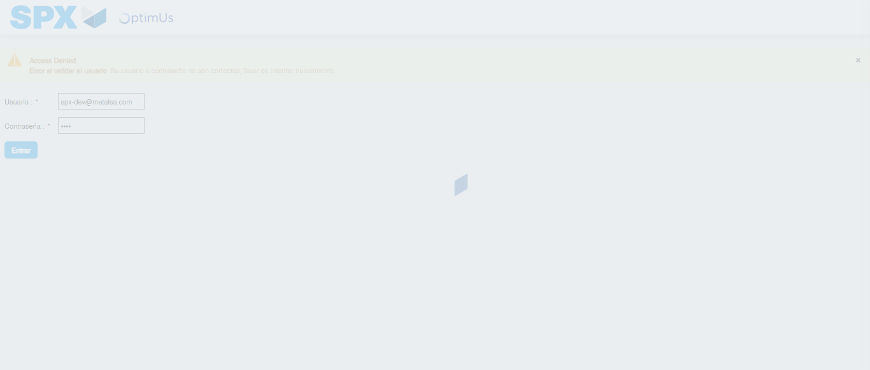Image file-name: QC_Testing-runTestMultipleTimes-nov. 25 2025, 04 04 43 p. m.

Step 2 - Select to UEN and Access to Spot Buy Requisitions : UEN Correctly selected and Correct access
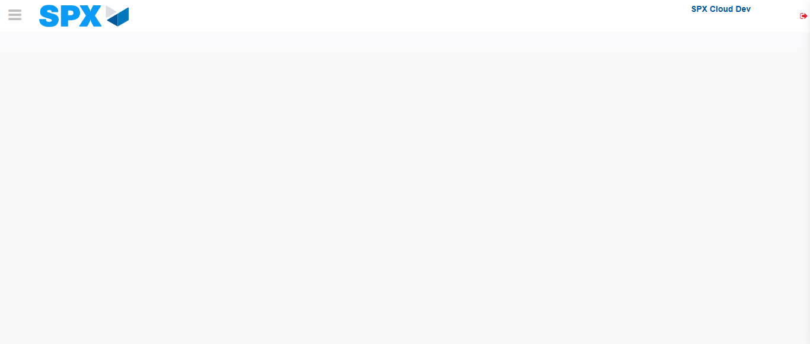Image file-name: QC_Testing-runTestMultipleTimes-nov. 25 2025, 04 04 52 p. m.

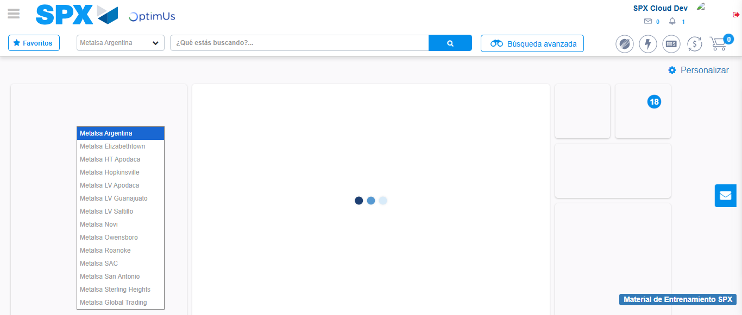Image file-name: QC_Testing-runTestMultipleTimes-nov. 25 2025, 04 04 53 p. m.

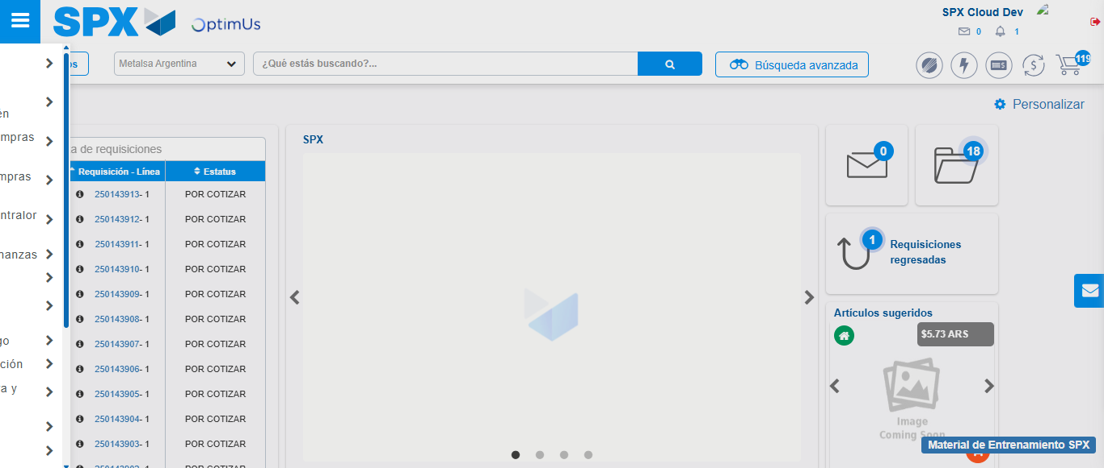Image file-name: QC_Testing-runTestMultipleTimes-nov. 25 2025, 04 04 54 p. m.

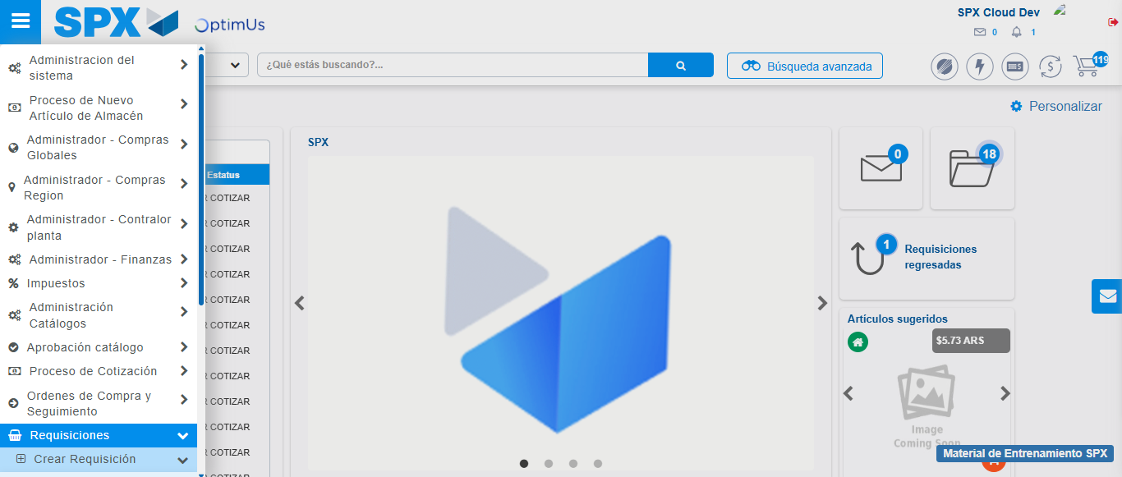Image file-name: QC_Testing-runTestMultipleTimes-nov. 25 2025, 04 04 55 p. m.

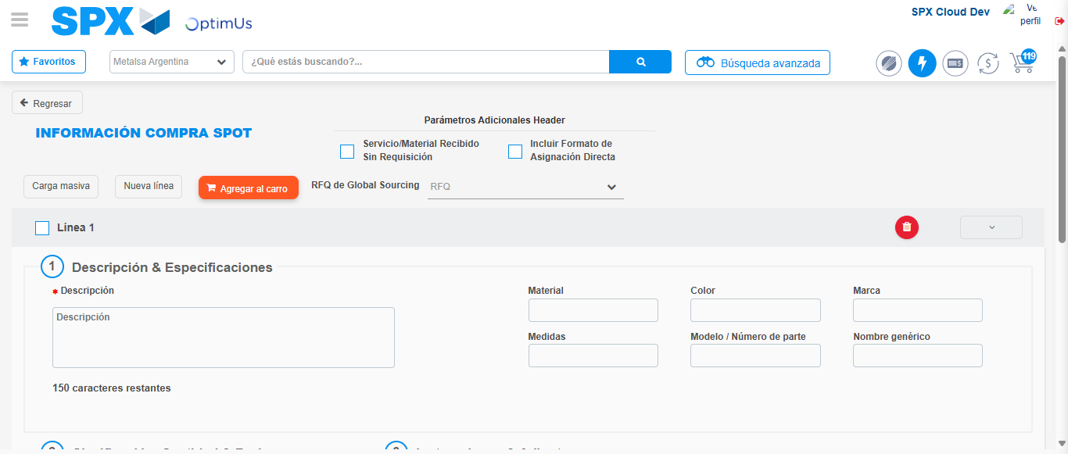Image file-name: QC_Testing-runTestMultipleTimes-nov. 25 2025, 04 04 59 p. m.

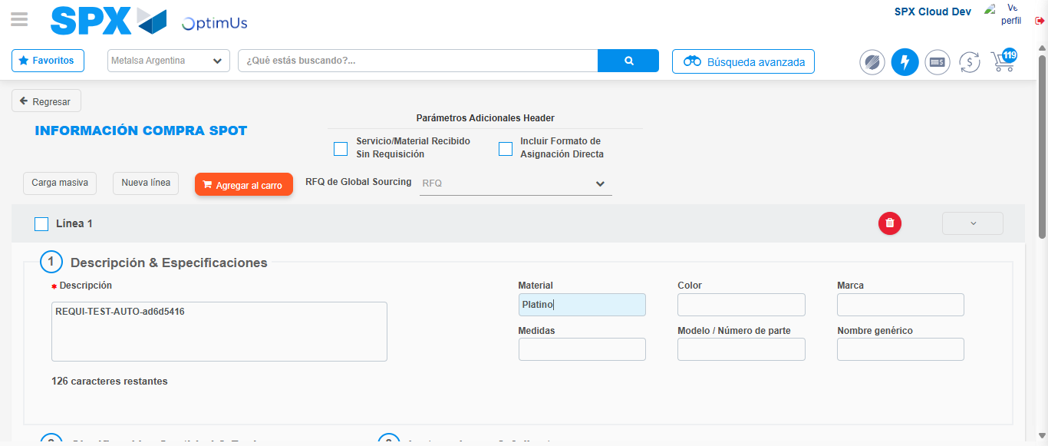Image file-name: QC_Testing-runTestMultipleTimes-nov. 25 2025, 04 05 00 p. m.

Step 3 - Data Capture Spot Buy Requisition : Data captured correctly
Image file-name: QC_Testing-runTestMultipleTimes-nov. 25 2025, 04 05 00 p. m.

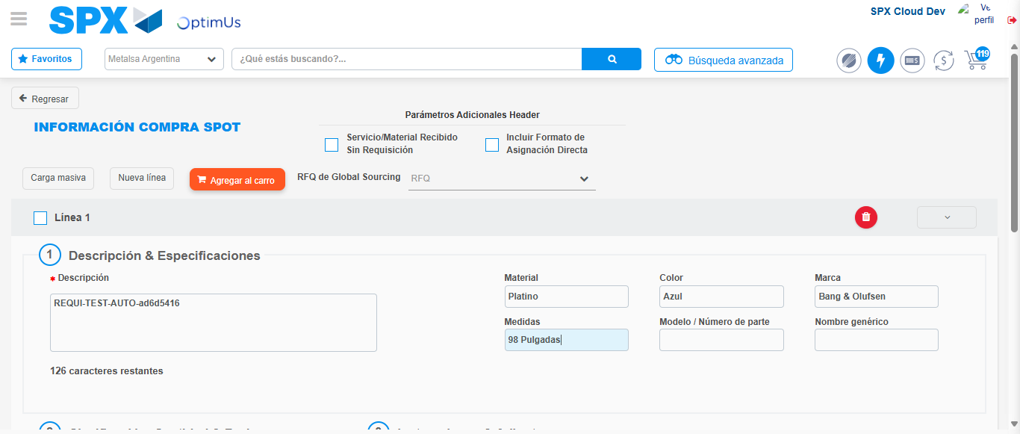Image file-name: QC_Testing-runTestMultipleTimes-nov. 25 2025, 04 05 01 p. m.

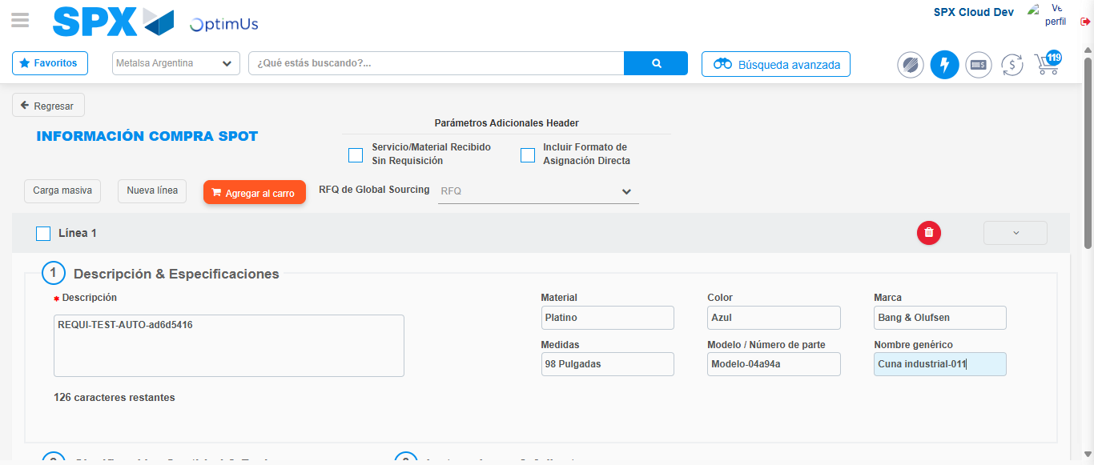Image file-name: QC_Testing-runTestMultipleTimes-nov. 25 2025, 04 05 02 p. m.

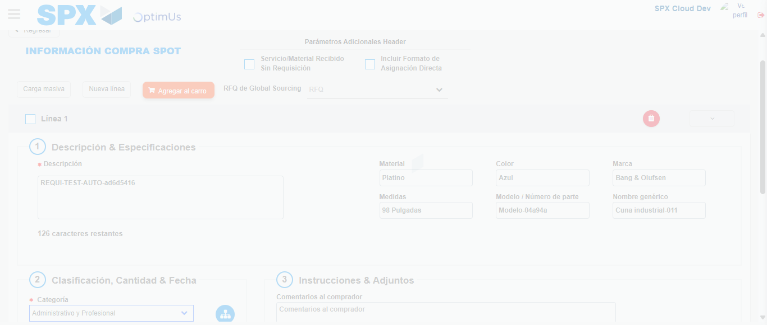Image file-name: QC_Testing-runTestMultipleTimes-nov. 25 2025, 04 05 03 p. m.

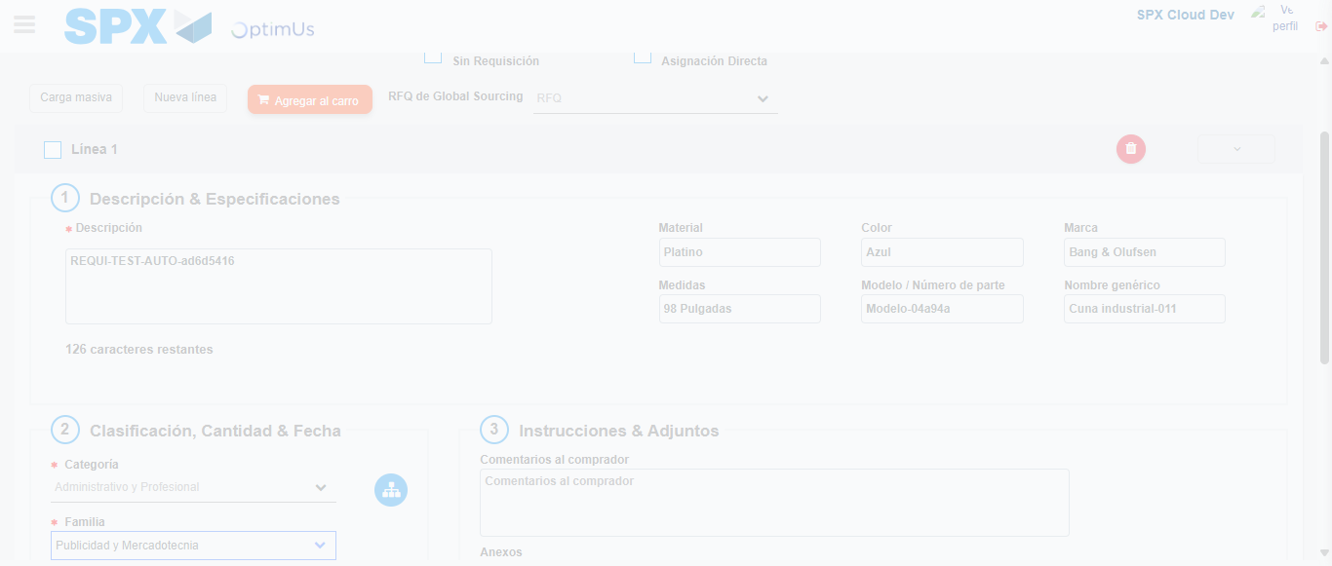Image file-name: QC_Testing-runTestMultipleTimes-nov. 25 2025, 04 05 04 p. m.

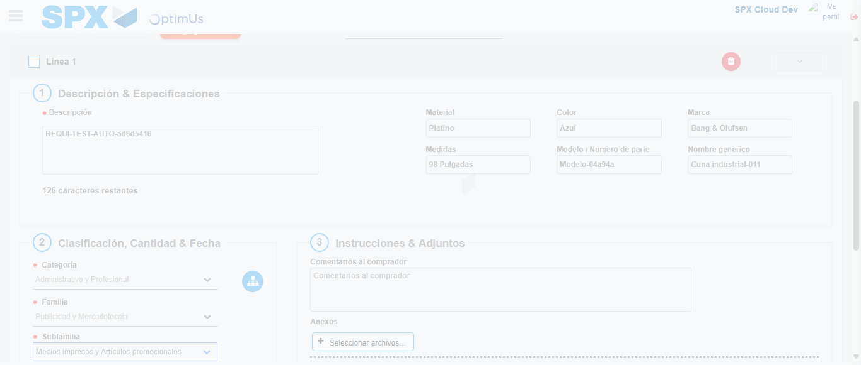Image file-name: QC_Testing-runTestMultipleTimes-nov. 25 2025, 04 05 08 p. m.

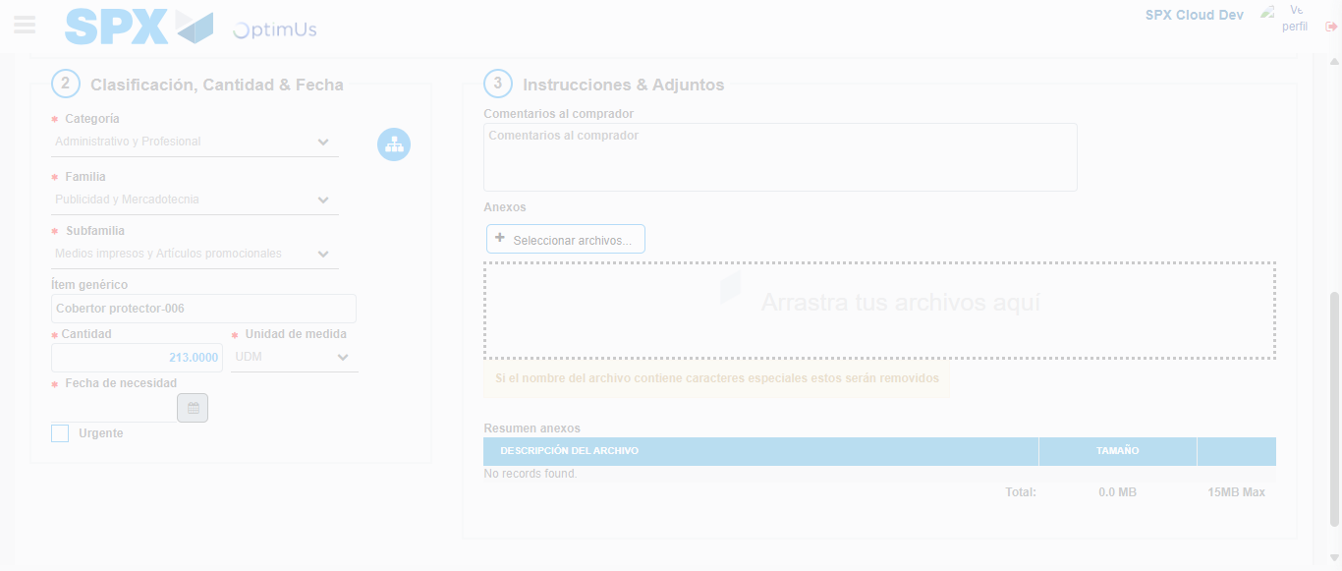Image file-name: QC_Testing-runTestMultipleTimes-nov. 25 2025, 04 05 09 p. m.

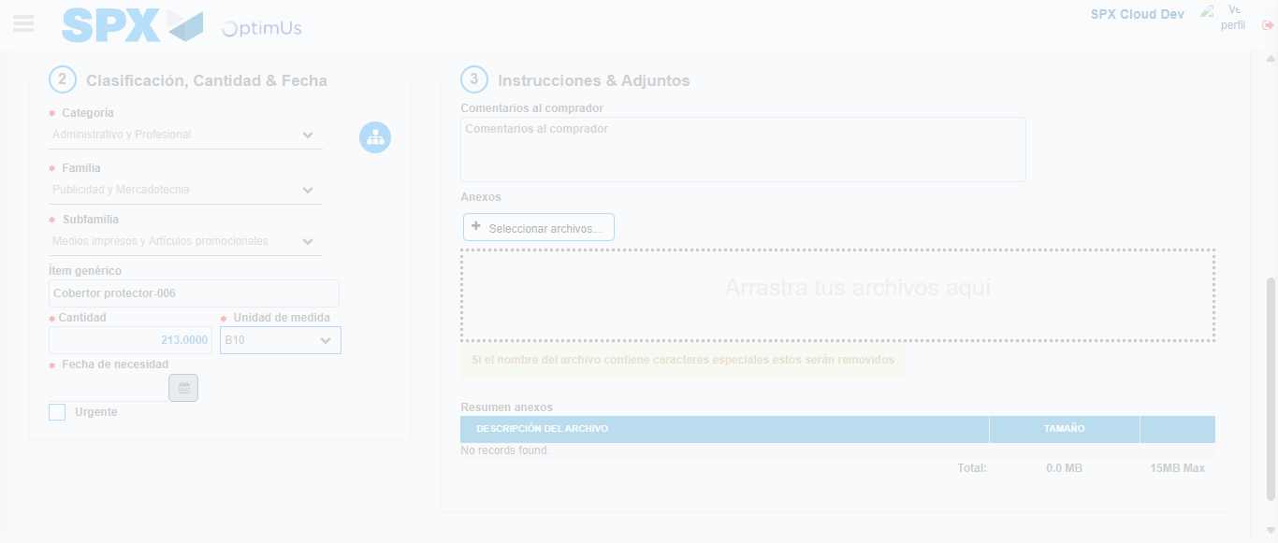Image file-name: QC_Testing-runTestMultipleTimes-nov. 25 2025, 04 05 10 p. m.

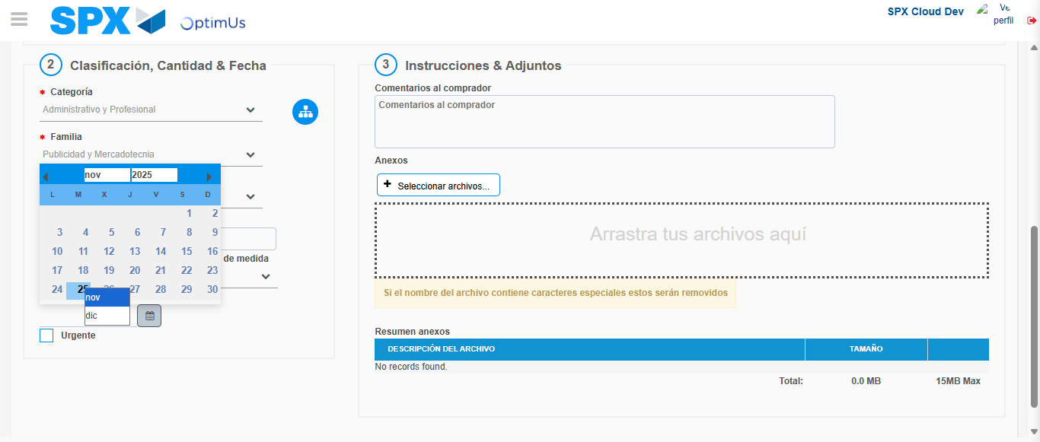Image file-name: QC_Testing-runTestMultipleTimes-nov. 25 2025, 04 05 11 p. m.

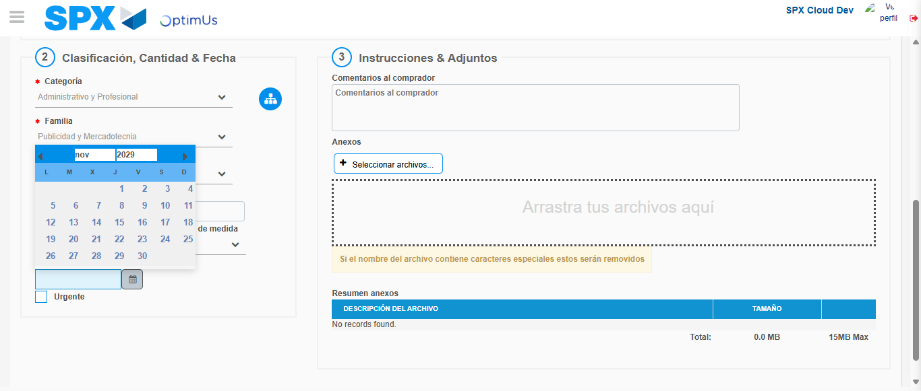Image file-name: QC_Testing-runTestMultipleTimes-nov. 25 2025, 04 05 12 p. m.

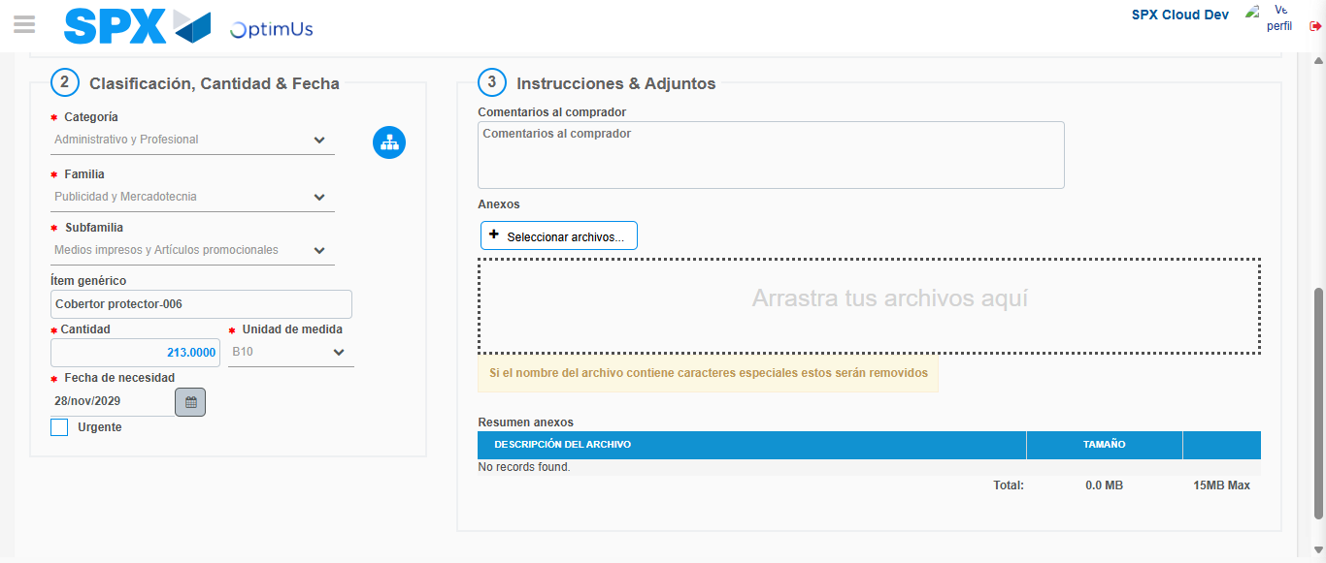Image file-name: QC_Testing-runTestMultipleTimes-nov. 25 2025, 04 05 13 p. m.

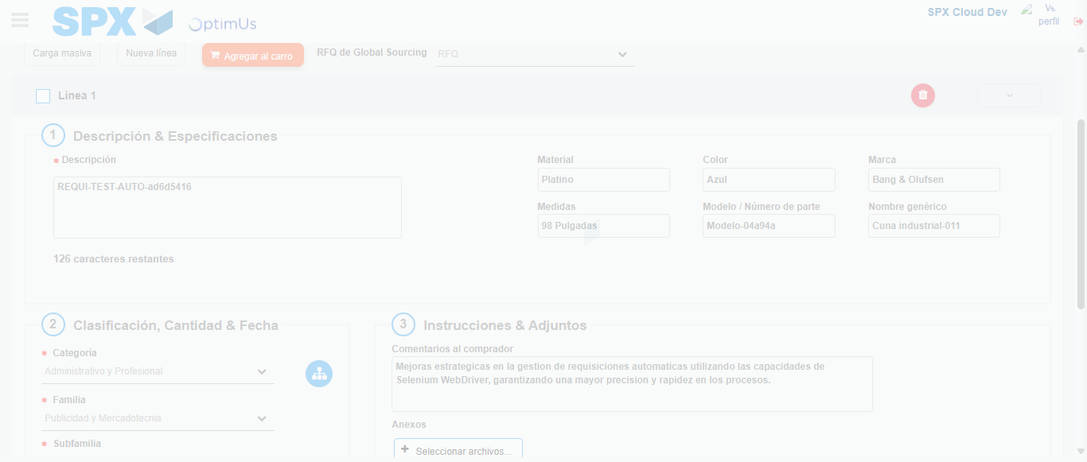Image file-name: QC_Testing-runTestMultipleTimes-nov. 25 2025, 04 05 14 p. m.

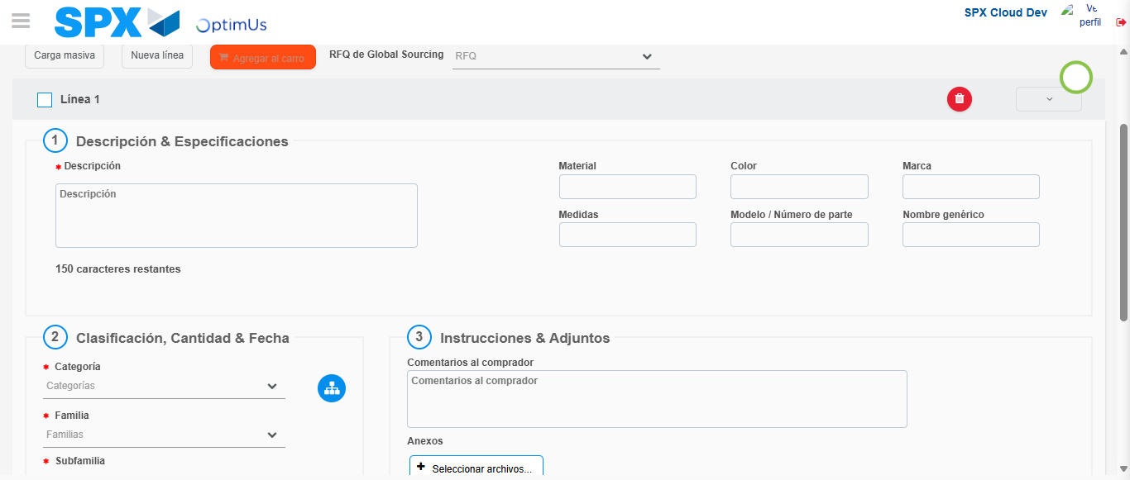Image file-name: QC_Testing-runTestMultipleTimes-nov. 25 2025, 04 05 15 p. m.

Step 4 - Select to Requisition : Requisition Correctly selected
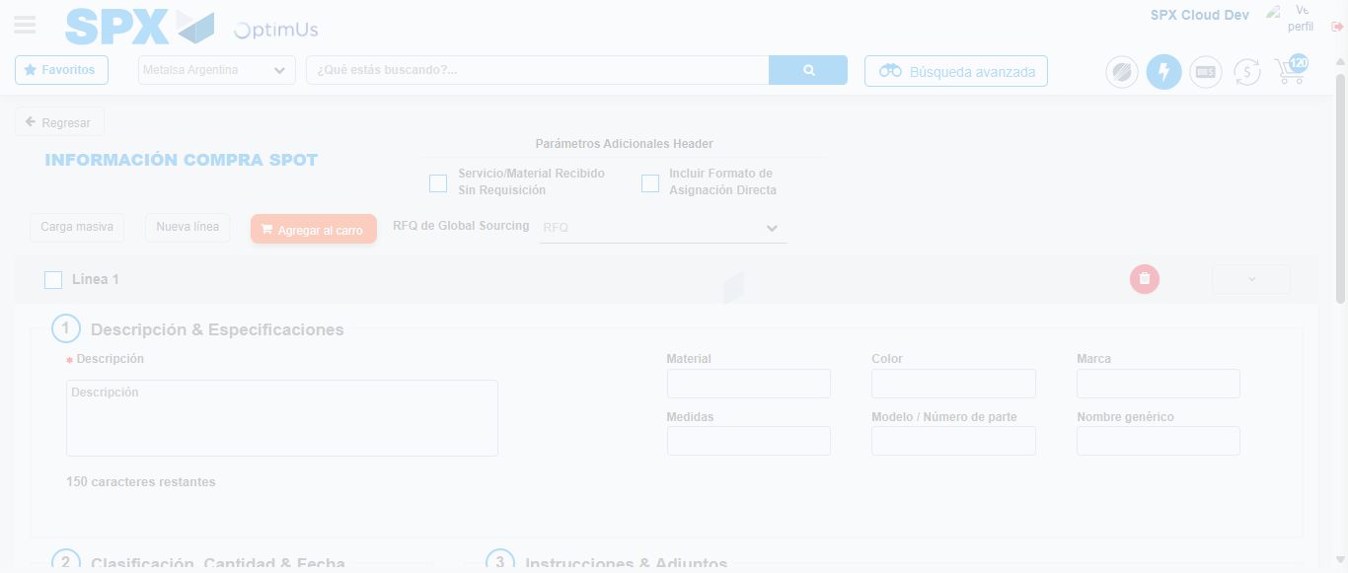Image file-name: QC_Testing-runTestMultipleTimes-nov. 25 2025, 04 05 24 p. m.

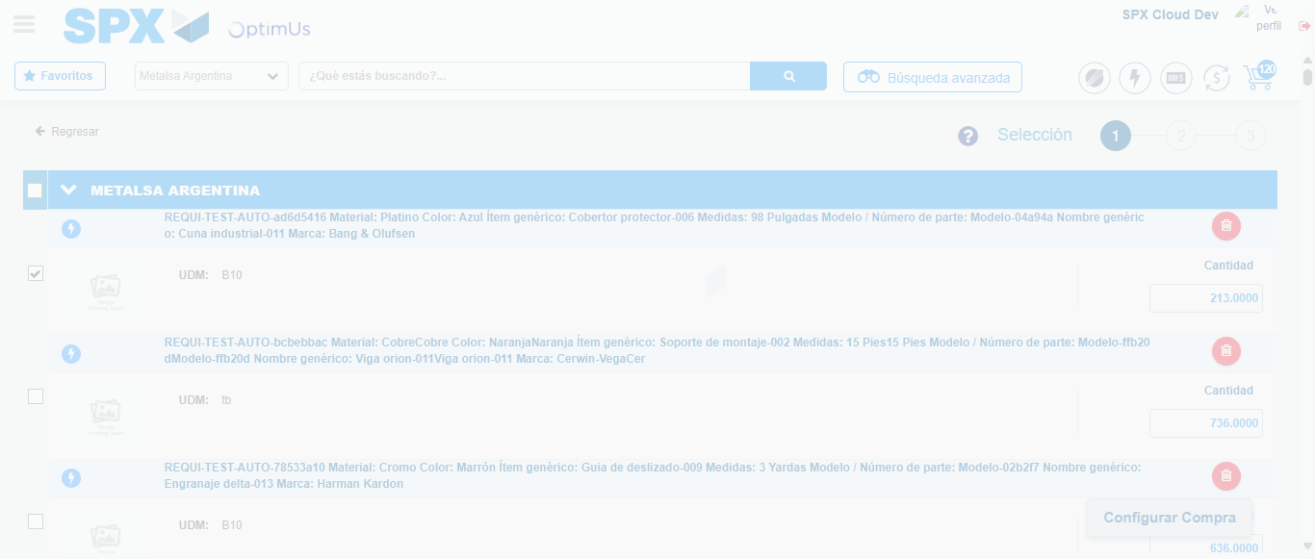Image file-name: QC_Testing-runTestMultipleTimes-nov. 25 2025, 04 05 25 p. m.

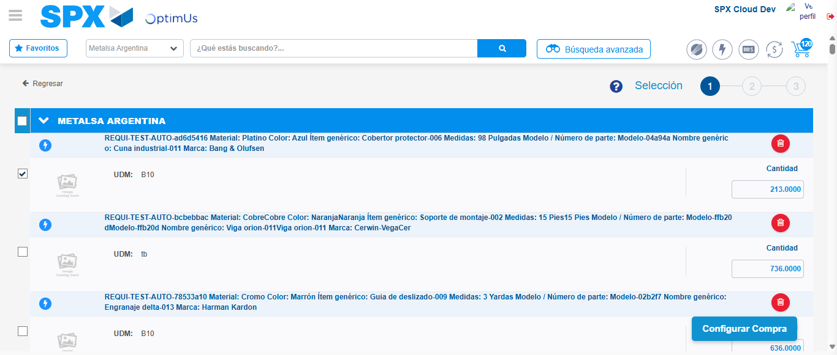Image file-name: QC_Testing-runTestMultipleTimes-nov. 25 2025, 04 05 28 p. m.

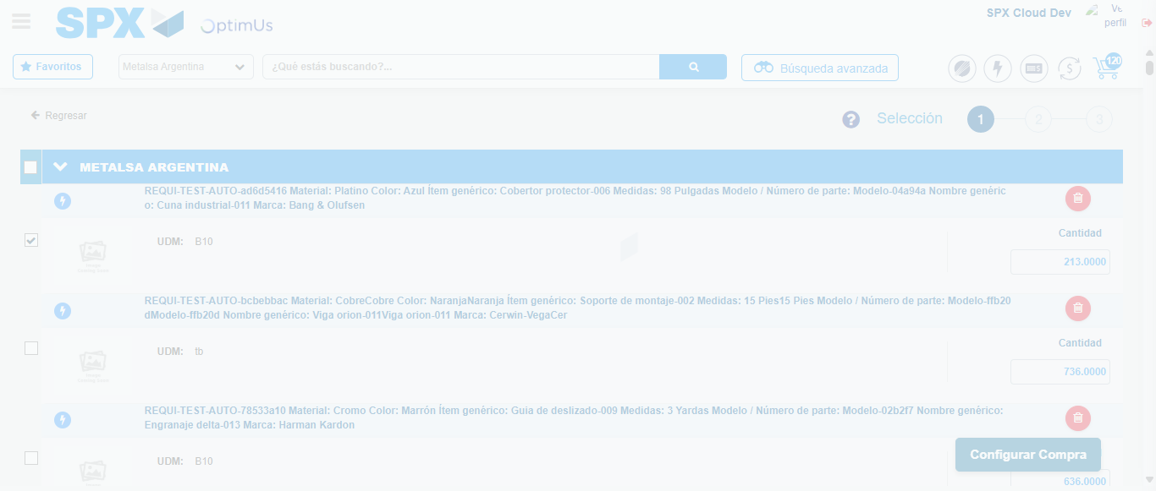Image file-name: QC_Testing-runTestMultipleTimes-nov. 25 2025, 04 05 29 p. m.

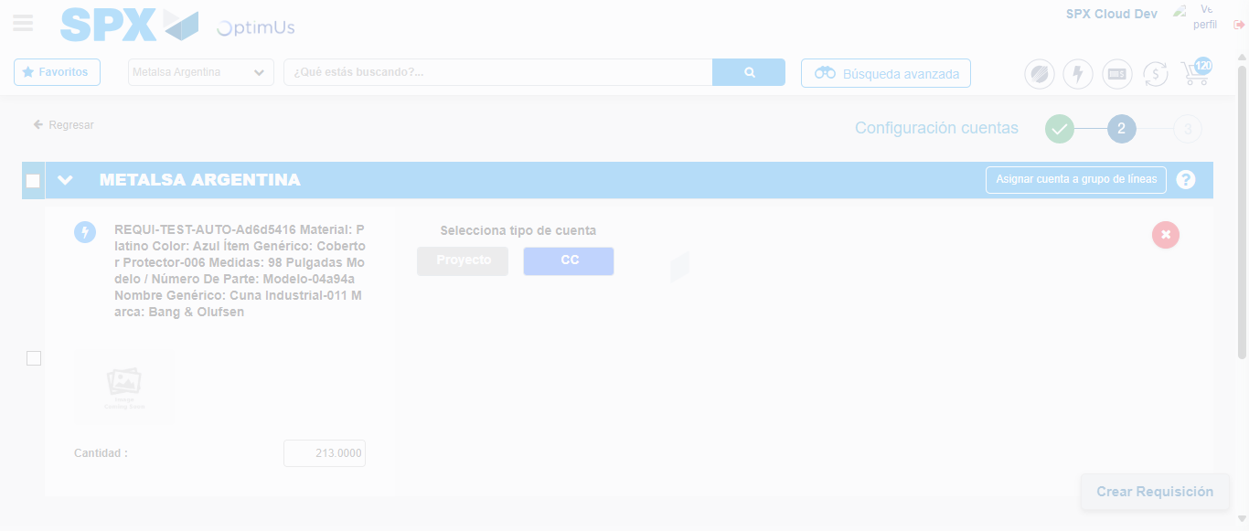Image file-name: QC_Testing-runTestMultipleTimes-nov. 25 2025, 04 05 33 p. m.

Step 5 - Select Type Account For Requisition : Type Account Correctly selected
Image file-name: QC_Testing-runTestMultipleTimes-nov. 25 2025, 04 05 33 p. m.

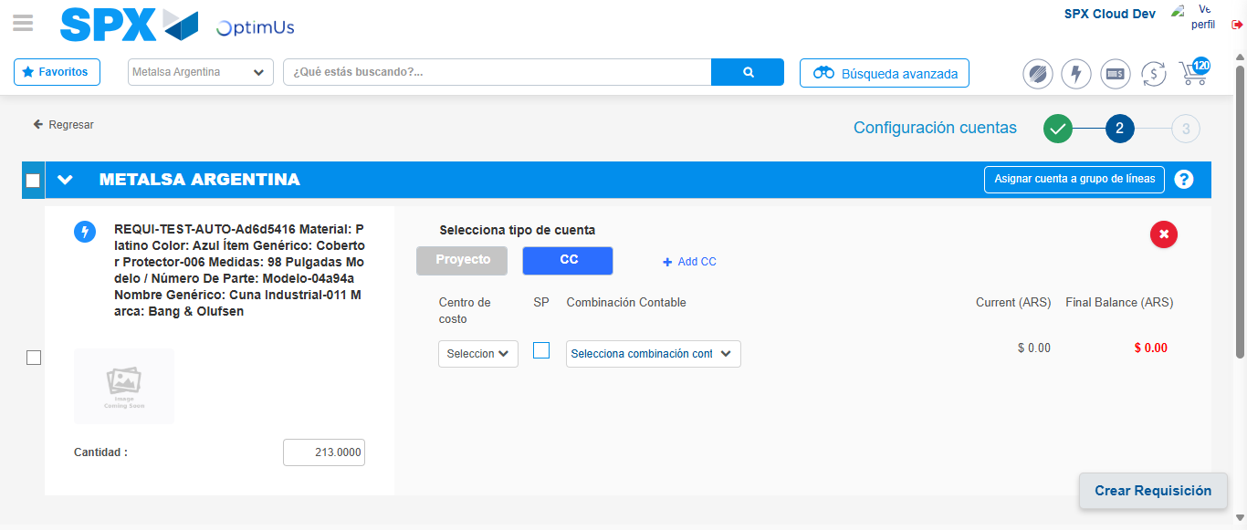Image file-name: QC_Testing-runTestMultipleTimes-nov. 25 2025, 04 05 37 p. m.

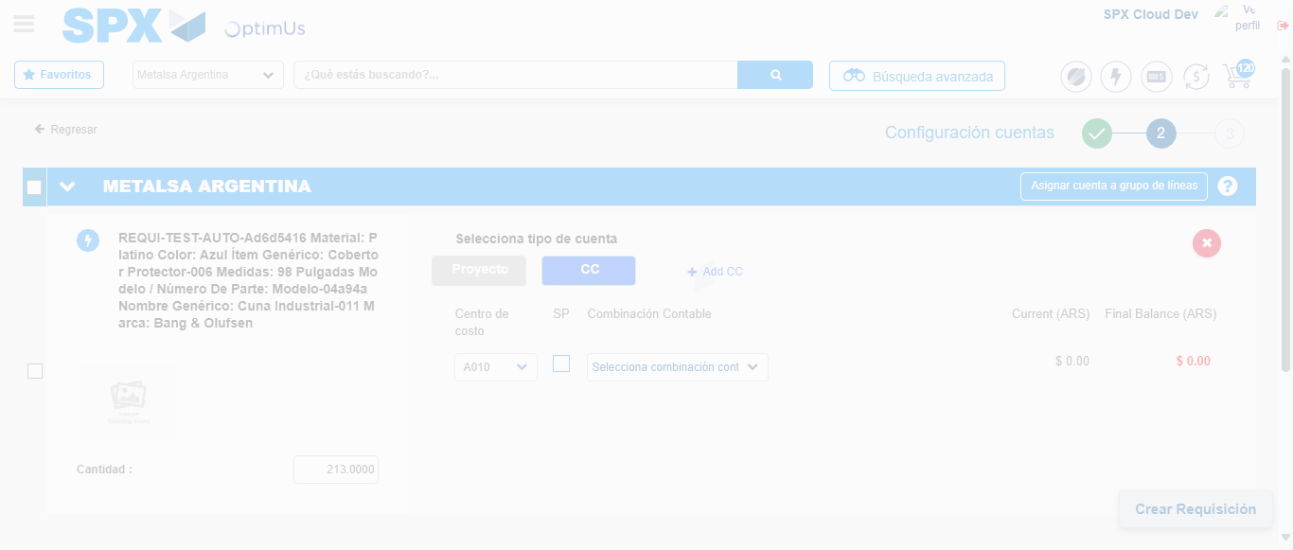Image file-name: QC_Testing-runTestMultipleTimes-nov. 25 2025, 04 05 40 p. m.

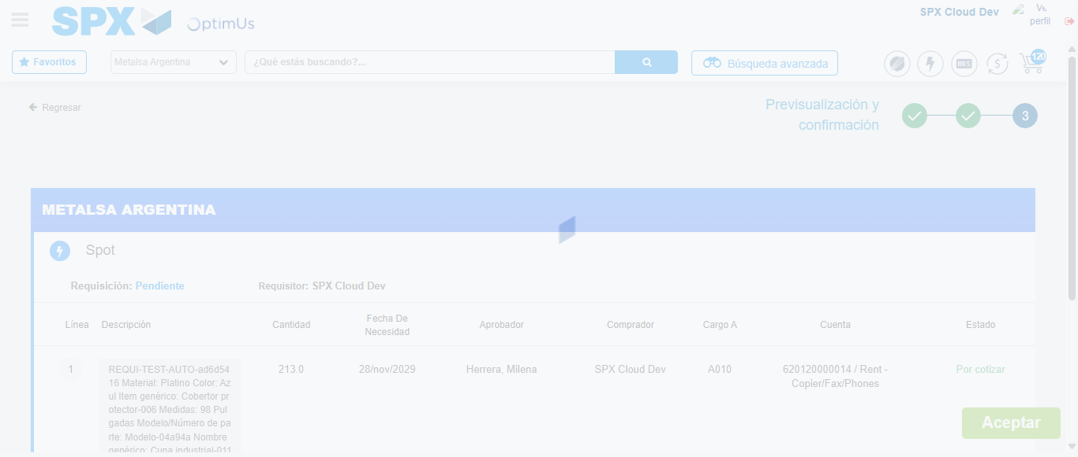Image file-name: QC_Testing-runTestMultipleTimes-nov. 25 2025, 04 05 44 p. m.

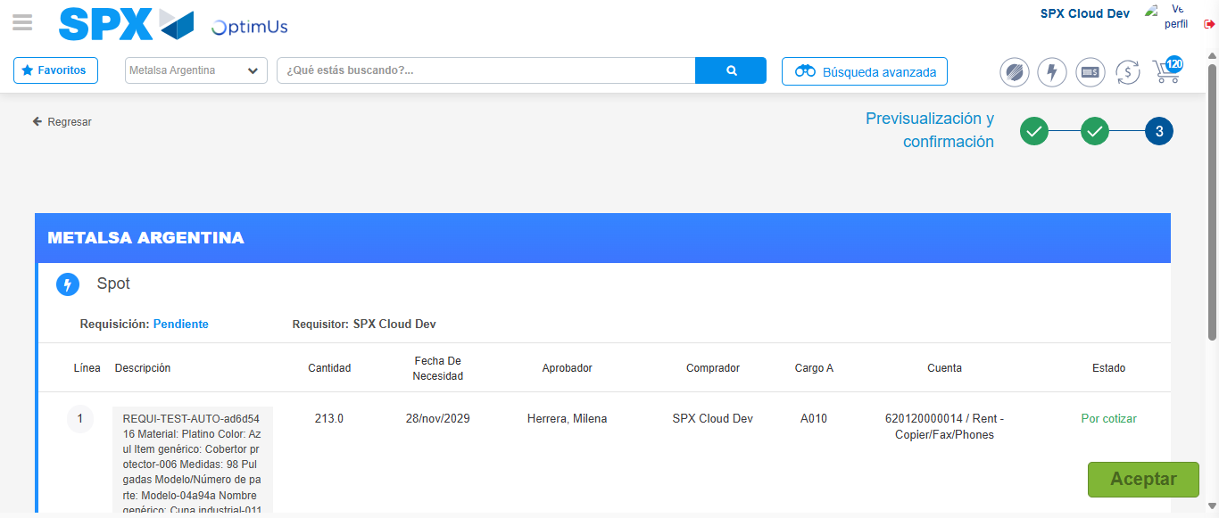Image file-name: QC_Testing-runTestMultipleTimes-nov. 25 2025, 04 05 47 p. m.

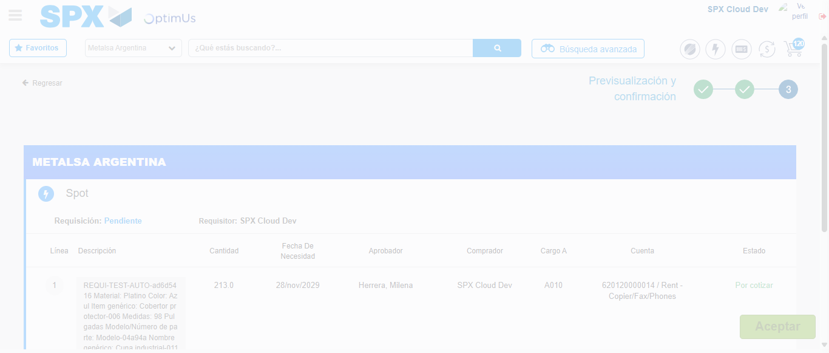Image file-name: QC_Testing-runTestMultipleTimes-nov. 25 2025, 04 05 48 p. m.

Step 6 - Accept to Requisition : Requisition Accepted
Image file-name: QC_Testing-runTestMultipleTimes-nov. 25 2025, 04 05 48 p. m.

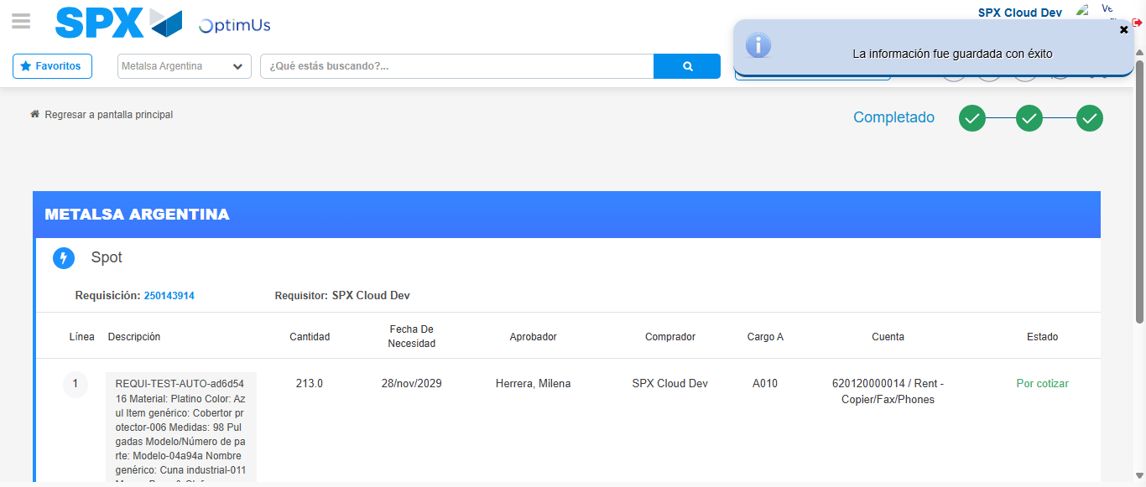Image file-name: QC_Testing-runTestMultipleTimes-nov. 25 2025, 04 05 51 p. m.

